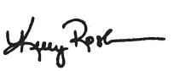

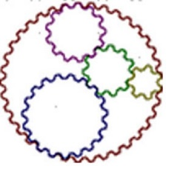

**Southern Ohio Council**

**A Council of Governments**

________________________

Kelly Rosler

Executive Director

Southern Ohio Council

of Governments



**ISSUE DATE**: 12/21/2023

**CERTIFICATE/REGISTRATION NUMBER:** 2023 - 044

**EFFECTIVE/EXPIRATION DATES:** 01/01/2024 - 01/01/2029

**NAME:**  Crystal Double

**TYPE:** Certification of County Board of DD Employees

**VALIDATION:** Business Manager

**STATUS:** Renewal